Website Planning & Documentation Report

1. Website Specifications
Website Name: Webb’s Motors
Website Objective:
The objective of the website is to provide an online platform for Webb’s Motors to showcase its automotive repair and panel beating services, attract new customers, and provide essential business information such as location, contact details, and services offered.
Website Goals:
- Promote services such as panel beating and spray painting
- Increase customer inquiries
- Provide easy access to contact details
- Build a professional online presence
- Showcase previous work
Target Audience:
Age: 18 years and above
Gender: All
Location: Gaborone and surrounding areas
Technical Ability: Basic to intermediate users
Type of Website:
Business / Service Website

2. Information Design & Taxonomy
Site Map:
Home (index.html)
- About Us (about.html)
- Services (services.html)
- Gallery (gallery.html)
- Contact (contact.html)
- Feedback (feedback.html)
Navigation Structure:
The website will use a top navigation bar visible on all pages. Users can access all pages within 2–3 clicks.
Content Organization:
- Home: Introduction and overview
- About: Company background
- Services: Services offered by the company
- Gallery: Images of work
- Contact: Contact form
- Feedback: Customer feedback
User Flow:
Users start on the Home page, navigate to Services or Gallery, then proceed to Contact to submit inquiries.

3. Technical Brief
Technologies Used:
- HTML5: Structure
- CSS3: Styling
- Bootstrap: Responsive design
- JavaScript: Interactivity
Development Tools:
- Notepad++: Code editor
- GitHub: Version control
- GitHub Pages: Hosting
Graphic Tools:
- GIMP / Canva: Image editing and design
Browser Compatibility:
Tested on Chrome, Firefox, Opera, and mobile devices.

4. Page template design

Home page ( index.htm)
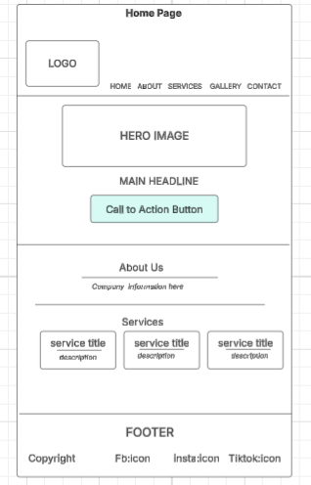
-designed to provide clear overview of the business. It begins with the Logo and Navigation Panel at the header, followed by a hero section containing a large image, main headline and a call to action button to capture user attention.
Below is the About Us section for brief introduction to the company, a services section displaying key services in clear separated content boxes.
The page ends with a footer containing copyright and Social Media Links
Contact Page (contact.html)
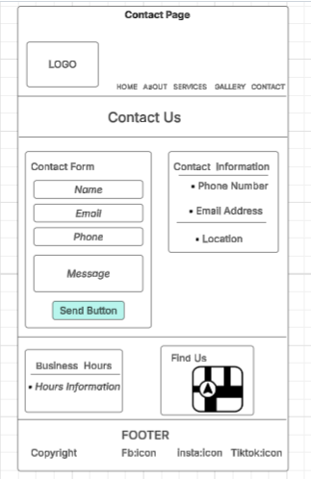
- Features a clearly defines contact form with input fields for name, email, phone number, message along with a submission button,
- A contact information section next to the contact input form, providing business contact details (phone number, email adress) and the Location
- Additional Sections like business hours and Map are included to improve accessibility and usability,

Services Page(services.html)
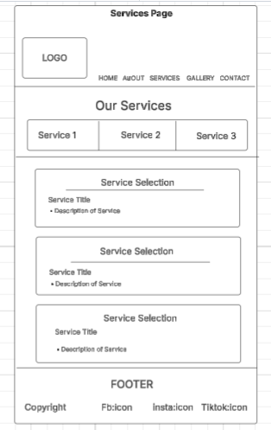
- This page presents the company’s offerings in a structured and easy to read format at the top, a service navigation or category section allows users to identify available services
- Below individual services sections are displayed each containing a service title and description. sections that are clearly separated and consistently arranged to ensure readability and easy navigation.

